Activities of the Department

An Induction Ceremony

An Induction Ceremony was conducted on 21 June 2017 to introduce the new First Year B.A students to the French department and its ways of functioning. The senior students put up a programme to break the ice and the new students displayed their talents through songs and skits.

French National Day

The Department organised a celebration on the occasion of the ‘Frencth National Day’ on the 14th July,2017. The event was attended by faculty and students of the French deparment as well as faculty and students of other departments, ex-students and a few guest teachers from other schools and colleges. The students of the department came up with various activities like skits, group songs and dance, and fashion shows which showcased the French culture. Ms. Ninette Gomes of F.Y.B.A presented a slide show on the important facts of France. A quiz was held, for the audience, based on this information.

Workshop

- A Workshop for teachers was conducted on the 12th of August 2017 by Miss. Natasha Gomes- (Faculty from Dept. of French- Goa University) on use of multimedia in classrooms, how to use various online French websites to enhance teaching skills and make the learning process more interesting and effective. Valuable information was provided to the teachers to be used in the teaching process on a day to day basis.

- A Culinary Workshop (Discovering French culinary secrets) was conducted by Ms. Charlene Weiss - Director of Alliance Française- Goa, on 22 February 2018. Ms. Weiss demonstrated the preparation of two famous French recopies. A culinary competition on French cuisine was also held for the students of the French Department..

Students visits to Pondicherry

The students of the French department visited Pondicherry for a period of one week from 15-22nd December 2017 with the view of understanding and learning the influence and impact of the French culture on this beautiful city.

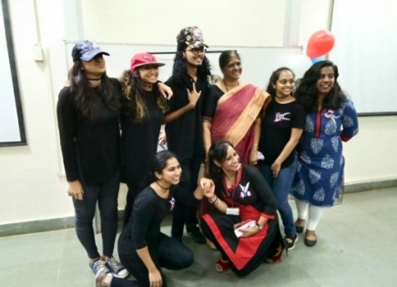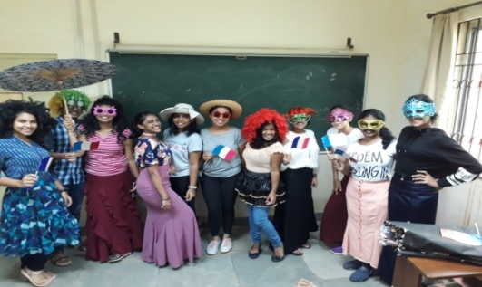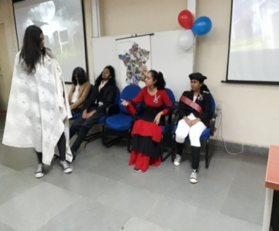
French National Day

